CAB BOOKING MANAGEMENT SYSTEM

SQL ANALYTICAL REPORT

Submitted By:
Anurag Kushwaha

Project Title:
Cab Booking Management System using MySQL

INTRODUCTION
The Cab Booking Management System is a database-driven application designed to manage customer bookings, driver assignments, and payment transactions. The system stores customer details, driver information, booking records, and payment status. SQL queries are used to analyze customer behavior, driver performance, revenue generation, and operational efficiency.

DATABASE TABLES

Customer
- user_id
- name
- email
- phone

Driver
- driver_id
- name
- vehicle_no
- phone
- rating

Bookings
- booking_id
- user_id
- driver_id
- pickup
- drop_location
- fare
- booking_time
- status
- rating
- distance
- trip_start_time
- cancellation_reason
- cab_type

Payment
- payment_id
- booking_id
- amount
- payment_method
- payment_status

CUSTOMER AND BOOKING ANALYSIS

1. Customers Who Completed the Most Bookings

Query:
SELECT c.user_id,c.name,COUNT(*) AS total_bookings
FROM Customer c
JOIN Bookings b ON c.user_id=b.user_id
WHERE b.status='Completed'
GROUP BY c.user_id,c.name
ORDER BY total_bookings DESC;

Output:
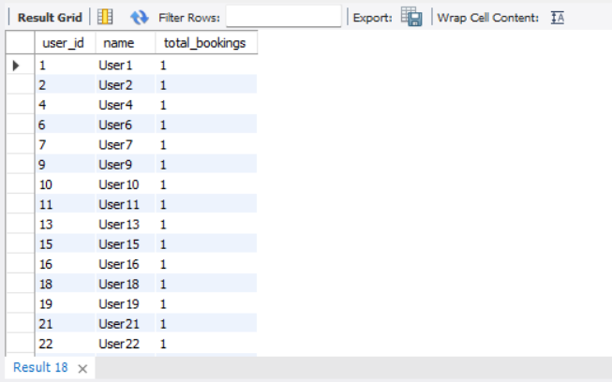

Insight:
These customers are loyal users and frequently use the service. They can be targeted with loyalty rewards and discounts.

2. Customers With More Than 30% Cancellations

Query:
SELECT c.user_id,c.name,COUNT(CASE WHEN b.status = 'Cancelled' THEN 1 END) AS cancelled_bookings,
COUNT(*) AS total_bookings,
ROUND(COUNT(CASE WHEN b.status = 'Cancelled' THEN 1 END) * 100.0/ COUNT(*),2) AS cancellation_percentage
FROM Customer c
JOIN Bookings b
ON c.user_id = b.user_id
GROUP BY c.user_id, c.name
HAVING ROUND(COUNT(CASE WHEN b.status = 'Cancelled' THEN 1 END) * 100.0/ COUNT(*),2) > 30
ORDER BY cancellation_percentage DESC;

Output:

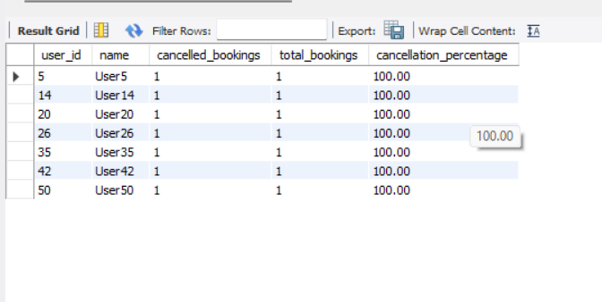

Insight:
Frequent cancellations may occur due to fare increases, long waiting times, or changes in travel plans.

3. Busiest Day of the Week

Query:
SELECT DAYNAME(booking_time) AS day_name,
COUNT(*) AS total_bookings
FROM Bookings
GROUP BY DAYNAME(booking_time)
ORDER BY total_bookings DESC;

Output:
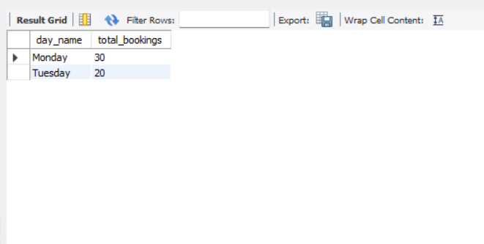

Insight:
The company should deploy more drivers during peak demand periods.

DRIVER PERFORMANCE AND EFFICIENCY

1. Drivers With Average Rating Below 3.0

Query:
SELECT driver_id,name,rating
FROM Driver
WHERE rating < 3.0
ORDER BY rating ASC;

Output:
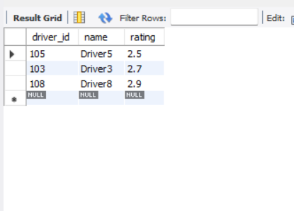

Insight:
Additional driver training and customer service improvements can increase ratings.

2. Top 5 Drivers Completing Longest Trips

Query:
SELECT driver_id,
SUM(distance) AS total_distance
FROM Bookings
GROUP BY driver_id
ORDER BY total_distance DESC
LIMIT 5;

Output:
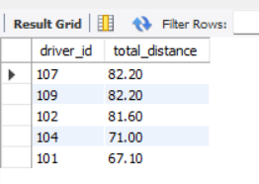

Insight:
These drivers likely handle long-distance routes and contribute significantly to revenue.

3. Drivers With High Cancellation Percentage

Query:

SELECT d.driver_id,d.name,COUNT(CASE WHEN b.status = 'Cancelled' THEN 1 END) AS cancelled_trips,COUNT(*) AS total_trips,ROUND(COUNT(CASE WHEN b.status = 'Cancelled' THEN 1 END) * 100.0/ COUNT(*),2) AS

cancellation_percentage

FROM Driver d

JOIN Bookings b

ON d.driver_id = b.driver_id

GROUP BY d.driver_id, d.name

HAVING cancellation_percentage > 20

ORDER BY cancellation_percentage DESC;

Output:

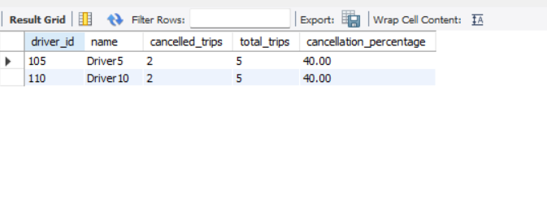Insight:

High cancellation rates may indicate reliability issues or operational challenges.

REVENUE AND BUSINESS METRICS

1. Total Revenue Generated

Query:
SELECT SUM(amount) AS total_revenue
FROM Payment
WHERE payment_status='Success';

Output:

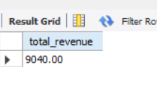

Insight:
Revenue reflects successful ride completions and customer payments.

2. Top 3 Most Frequently Travelled Routes

Query:
SELECT pickup,
drop_location,
COUNT(*) AS total_trips
FROM Bookings
GROUP BY pickup,drop_location
ORDER BY total_trips DESC
LIMIT 3;
Output:
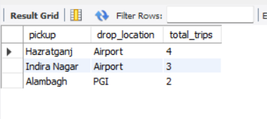

Insight:
More drivers should be allocated to these high-demand routes.

3. Driver Ratings vs Earnings

Query:
SELECT driver_id,
AVG(rating),
SUM(fare)
FROM Bookings
GROUP BY driver_id;

Output:
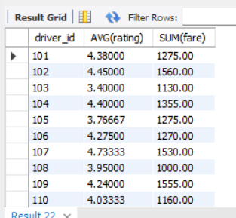

Insight:
Highly rated drivers may earn more due to increased customer trust.

OPERATIONAL EFFICIENCY

1. Average Waiting Time

Query:
SELECT pickup_location,
AVG(TIMESTAMPDIFF(MINUTE,booking_time,trip_start_time))
FROM Bookings
GROUP BY pickup_location;

Output:
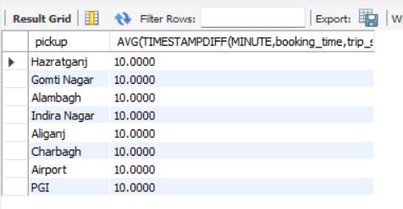

Insight:
Reducing wait times improves customer satisfaction.

2. Common Cancellation Reasons

Query:
SELECT cancellation_reason,
COUNT(*)
FROM Bookings
GROUP BY cancellation_reason;

Output:
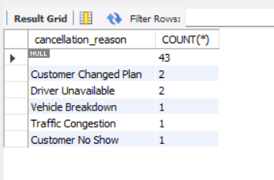
Insight:
Understanding cancellation causes helps improve service quality.

3. Short Trip Revenue Analysis

Query:
SELECT
CASE
WHEN distance<5 THEN 'Short Trip'
ELSE 'Long Trip'
END as Trip_Category,
SUM(fare)
FROM Bookings
GROUP BY 1;

Output:
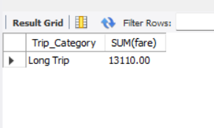

Insight:
Short trips may contribute significantly to daily ride volume.

COMPARATIVE AND PREDICTIVE ANALYSIS

1. Sedan vs SUV Revenue

Query:
SELECT cab_type,
SUM(fare)
FROM Bookings
GROUP BY cab_type;

Output:
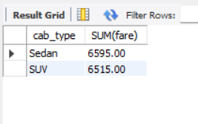

Insight:
Revenue comparison can guide future fleet investments.

2. Customer Churn Prediction

Query:
SELECT user_id,
MAX(booking_time) AS last_booking,
COUNT(*) AS total_bookings
FROM Bookings
GROUP BY user_id
ORDER BY last_booking;

Output:
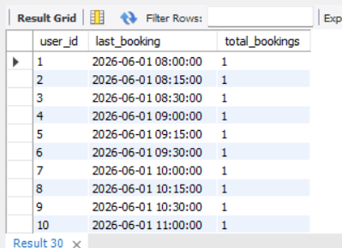

Insight:
Customers who have not booked recently may be at risk of leaving the platform.

3. Weekend vs Weekday Booking Analysis

Query:
SELECT
CASE
WHEN DAYOFWEEK(booking_time) IN (1,7)
THEN 'Weekend'
ELSE 'Weekday'
END AS booking_type,
COUNT(*) AS total_bookings,
SUM(fare) AS revenue
FROM Bookings
GROUP BY booking_type;

Output:
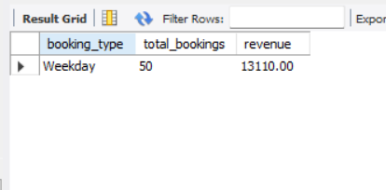
Insight:
Dynamic pricing can be introduced during periods of high demand.

CONCLUSION
The Cab Booking Management System demonstrates how SQL can be used to analyze customer behavior, driver efficiency, revenue generation, and operational performance. The project helps management make data-driven decisions, optimize resource allocation, improve customer satisfaction, and increase profitability. Future enhancements will allow deeper business intelligence and predictive analytics capabilities.

